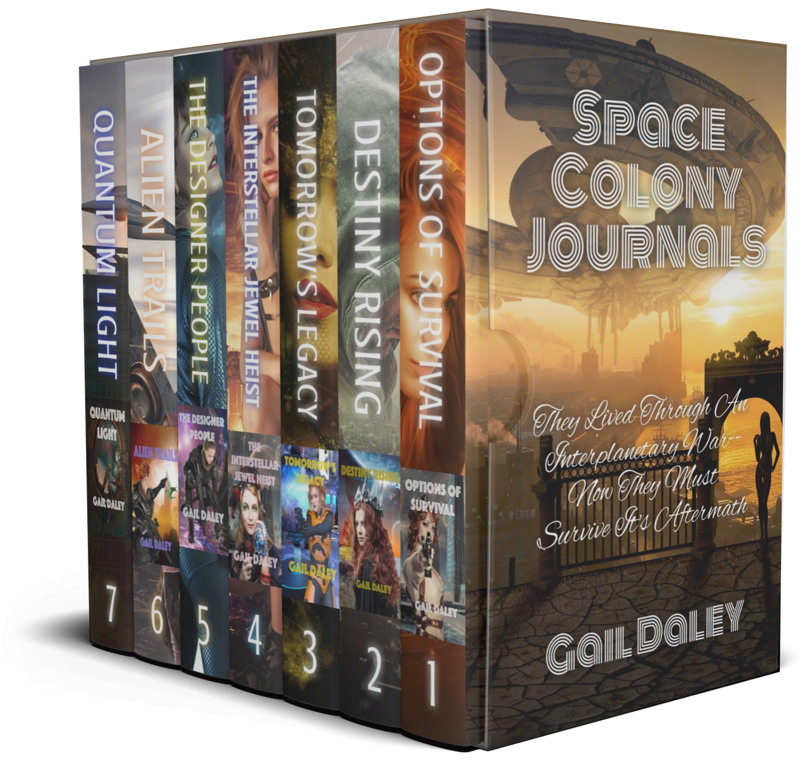
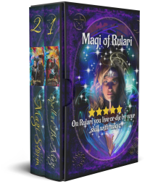
Jan 2021-4
Science Fiction | Fantasy | Romance
Gail Daley
Women In Fiction
‘Everyone’ says that until the 1970’s women appearing in Science Fiction books were either sex objects, damsels in distress, or sometimes a villainess. ‘Everyone’ also claims that women who wrote Sci-Fi wrote under men’s names in order to get published. This is certainly true of Grandmaster Alice Mary Norton (Andre Norton).
Is this true? Well, sort of. Women in Classic Science Fiction books (and I include comic books and graphic novels in this) usually were not portrayed as physically or mentally formidable. (For instance, ALL the mad scientists I’ve read about from the pulp era were men). What we need to remember: Classic Science fiction was written just after WWII. Women had only been considered legal entities since 1922 when married women were able to inherit property control it. We’ve come a long way baby!
If you are interested in reading more on this subject, I can recommend: https://www.theguardian.com/money/us-money-blog/2014/aug/11/women-rights-money-timeline-history
And
https://www.wired.com/2019/02/geeks-guide-history-women-sci-fi/

Strong Female Leads
Books in this promotion feature strong women who can (and are allowed) to stand on their own feet.
Promotion ends on Jan 31, 2021

https://books.bookfunnel.com/strong_female_lead/9zkfl6mwtv

REVIEWS MATTER!
And please don't forget--Honest reviews are critical to all authors - please take two minutes to tell us what YOU think of our work. Reviews don't have to be long and analytical. Just say what you think as though chatting with a friend. PLEASE, ALWAYS WRITE A REVIEW for any book you read or audiobook you listen to.
If you would like to get free advance copies of my books, I have a few spaces left for ARC readers who are willing to provide a review of my books.
Preferred Format (check one)
_____ E-Pub ____ Mobi
The 3rd book in The Forbidden Colony Series: Gaslight Bandits is out now. A first month promotional price of 99¢ will be in effect until Jan 31st. Learn More

I just posted some new book promotions on my web site. To Find Out More Click here:
https://gaildaley.com/Promotions--Discounts-and-Free-Books.php
You received this email because you signed up on my website or agreed to receive the newsletter during a book promotion. I add readers to my mailing lists from Book Funnel, AuthorXPromotions and a few other promotional sites that promote books by multiple authors. I write in several genres so a few of my books do cross multiple genres, so you may receive a newsletter from me announcing a promotion because I am promoting a book that meets the general description of the genre.
To Unsubscribe from this list, please use your 'reply to sender' button with the subject line "Please Unsubscribe Me From This List"
A copy of my Privacy policy is available at www.gaildaley.com

