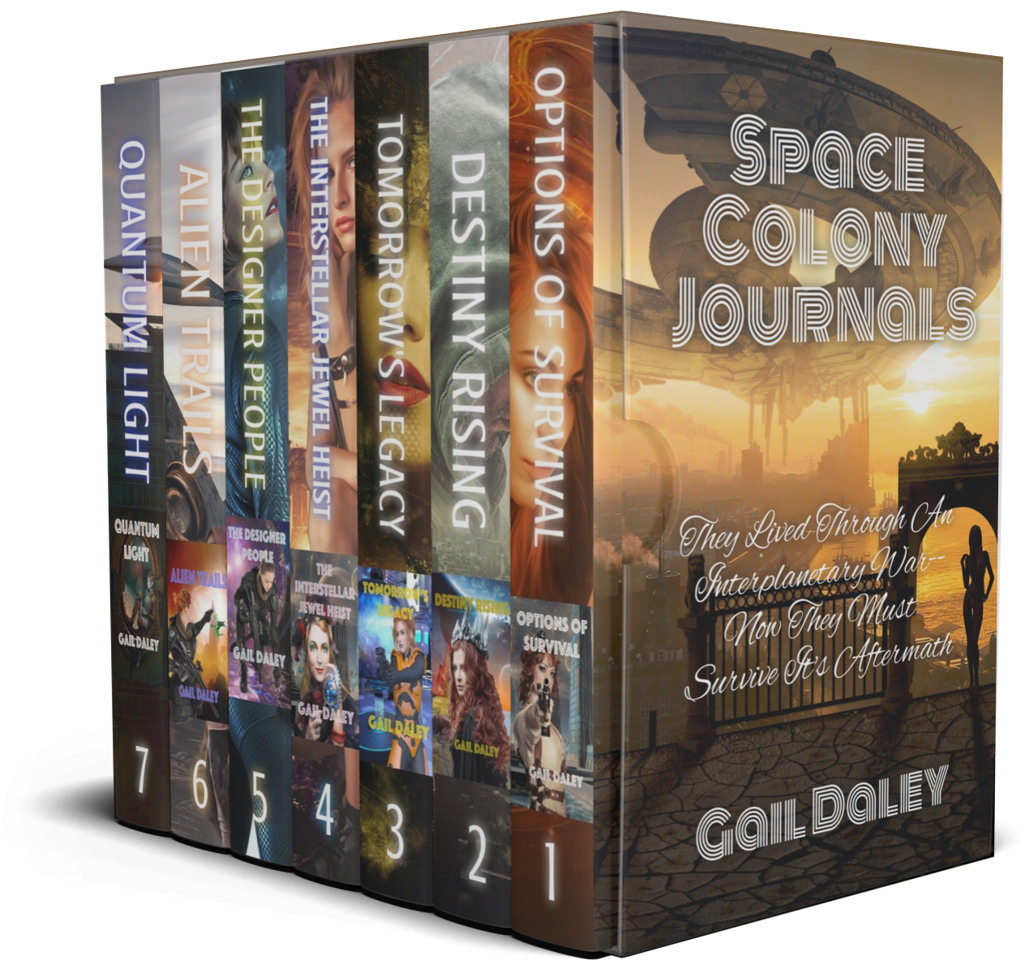
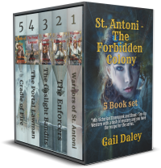
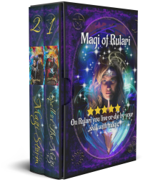
Jan 2021-5
Science Fiction | Fantasy | Romance
Gail Daley

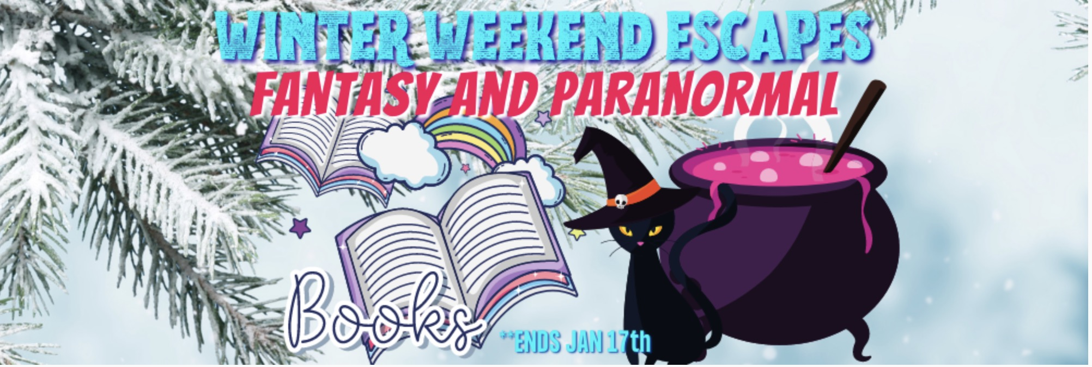
.
Weekend Fantasy Book Blast
Jan 14 – Jan 17, 2021
4 Day Sale! Don’t wait to Explore new worlds with these great reads!” Grab your books before they are all gone!
I was happy to find a promotion like this one where I can include the first two books of my fantasy series: The Magi of Rulari. A lot of authors apparently felt the same way because they've included some fabulous reads here.

https://books.bookfunnel.com/4daysonlyfantasyparanormalbooks/t8gxmf14l5

WHAT IS FANTASY?
Fantasy is a fiction genre set in an imaginary universe, most often without any locations, events, or people from the real world. Most fantasy uses magic or other supernatural elements as a main plot element, theme, or setting. Magic and magical creatures are common in these imaginary worlds. Fantasy is generally separated from the genres of Science Fiction and Horror by steering clear of scientific and macabre themes. There are a lot of common characteristics among the three however, all of which are subgenres of speculative fiction, and I have included Horror as a sub-genre of fantasy.
Urban Fantasy: is a subgenre of fantasy defined by where it takes place; it is a fantastic narrative with an urban setting. Urban fantasy exists on one side of a scale opposite high fantasy, which is set in an entirely made-up world. Many urban fantasies are set in present-day times with supernatural elements. However, the stories can take place in historical, modern, or futuristic periods. The prerequisite is that they must be primarily set in a city.
Contemporary Fantasy: is generally distinguished from Urban Fantasy and Horror fiction—which also have contemporary settings and fantastic elements—from Horror by the overall tone; emphasizing joy or wonder rather than fear or dread, and from Urban Fantasy in that the setting doesn't have to be a city. These are stories set in the accepted real world in contemporary times; magic and magical creatures exist but are not commonly seen or understood. They exist by either living in underbelly of our world or by leaking over from alternate worlds. It has much in common with, and sometimes overlaps, secret history. FYI: A work of fantasy where the magic does not remain secret, or does not have any known relationship to known history, would not fit into this subgenre.
Traditional Fantasy: Please see the definition of Fantasy above.
Horror: This is a genre of fiction which is intended to frighten, scare, disgust, or startle readers or viewers by inciting feelings of horror and terror. Literary historian J. A. Cuddon defined the horror story as "a piece of fiction of variable length... which shocks or even frightens the reader, or perhaps induces a feeling of repulsion or loathing". Horror creates an eerie and frightening atmosphere. Horror is frequently supernatural though it doesn't have to be. Occasionally the menace in a work of horror fiction can be interpreted as a metaphor for the larger fears of a society.
Historical Fantasy: This is a category of fantasy and a sub genre of historical fiction that combines magic elements into the story. There is much crossover with other subgenres of fantasy. Books classified as Arthurian, Celtic, or Dark Ages could just as easily be placed in Historical Fantasy. Stories fitting this classification generally take place prior to the 20th century.
Weird Fiction: This is a subgenre starting in the late 19th and early 20th century. It can include ghost stories and other tales of the macabre. Weird fiction is distinguished from Horror and Fantasy in its blending of supernatural, mythical, and even scientific elements. British authors who have embraced this style have published their work in mainstream literary magazines. American weird fiction writers included Edgar Allan Poe, William Hope Hodgson, H. P. Lovecraft, Lord Dunsany, Arthur Machen M. R. James, and Clark Ashton Smith.
Comic Fantasy: This s a subgenre of fantasy that is humorous in intent and tone. Usually set in imaginary worlds, comic fantasy can spoof and parody other works of fantasy, detective fiction or other genres. It is sometimes known as Low Fantasy in contrast to High Fantasy, which is primarily serious in intent and tone. The term "low fantasy" is used to represent other types of fantasy too though, so while comic fantasies may correctly be classified as low fantasy, many examples of low fantasy are not comic in nature. Two of the most famous examples in this genre would be Robert Lynn Aspin's Myth Series which successfully spoofed Fantasy, and the Garrett P.I. series by Glen Cook, which did a parody of Rex Stout's Nero Wolfe detective series. Other writers of comic fantasy are emerging; notably Dakota Cassidy with her werewolf/witch spoofs and Amanda M. Lee's Wicked Witches of the Midwest series.
Slipstream: Slipstream is a kind of fantastic or non-realistic fiction that crosses traditional genre borders between science fiction, fantasy, and literary fiction. Slipstream falls between Speculative Fiction and Mainstream Fiction. While some slipstream novels employ elements of Science Fiction or Fantasy, not all do. A few examples of this are Slaughterhouse Five by Kurt Vonnegut, Anna Kavans Ice, or Magic for beginners by Kelly Link.
Epic / High Fantasy: High Fantasy, sometimes referred to as Sword & Sorcery, is a subgenre of fantasy, and is defined by its setting in a fictional universe or by the larger-than-life stature of its characters, themes, and plot. The term "High Fantasy" was coined by Lloyd Alexander in a 1971 essay, "High Fantasy and Heroic Romance" (originally given at the New England Round Table of Children's Librarians in October 1969). Epic Fantasy has been described as containing three elements: it must be a trilogy or longer, its time-span must encompass years or more, and it must contain a large back-story or universe setting in which the story takes place. (Think Lord of the Rings).

REVIEWS MATTER!
And please don't forget--Honest reviews are critical to all authors - please take two minutes to tell us what YOU think of our work. Reviews don't have to be long and analytical. Just say what you think as though chatting with a friend. PLEASE, ALWAYS WRITE A REVIEW for any book you read or audiobook you listen to.
If you would like to get free advance copies of my books, I have a few spaces left for ARC readers who are willing to provide a review of my books.
Preferred Format (check one)
_____ E-Pub ____ Mobi

The 3rd book in The Forbidden Colony Series: Gaslight Bandits is out now. A first month promotional price of 99¢ will be in effect until Jan 31st. Learn More

I just posted some new book promotions on my web site. To Find Out More Click here: https://gaildaley.com/Promotions--Discounts-and-Free-Books.php
You received this email because you signed up on my website or agreed to receive the newsletter during a book promotion. I add readers to my mailing lists from Book Funnel, AuthorXPromotions and a few other promotional sites that promote books by multiple authors. I write in several genres so a few of my books do cross multiple genres, so you may receive a newsletter from me announcing a promotion because I am promoting a book that meets the general description of the genre.
To Unsubscribe from this list, please use your 'reply to sender' button with the subject line "Please Unsubscribe Me From This List"
A copy of my Privacy policy is available at www.gaildaley.com

